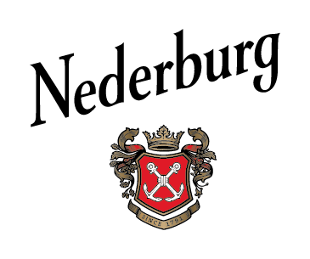

SWITCH ON YOUR SENSES AT NEDERBURG’S THE MANOR

It is said that that ‘we eat with our eyes’, and this summer, Nederburg is putting this concept to the test by stripping away some senses and enhancing others to show just how you perceive wine, food and flavours using different senses. The Manor restaurant, situated in Nederburg’s historic manor house that dates to 1800, will be offering a Five Senses Food & Wine Experience, starting in December.

Savour some refreshing Cap Classique on arrival, followed by three mini food courses, each beautifully matched with one of Nederburg’s fine wines, whilst blindfolded and with wireless headphones filling your ears with music. Then try the same line-up of food and wine, but this time, without the blindfold and headphones. Experience how your perception of flavour changes.

Niël Groenewald, Nederburg’s MD, comments: “When one sense is taken away, the others work harder to help you identify what you’re eating and/or drinking. For example, without sight, your senses of taste and smell are heightened while your imagination is enhanced. We eat and drink with our eyes much more than we realise! Meanwhile, with sound added, it becomes even more of a perception-shifting exercise.”

Nederburg’s Five Senses Food & Wine Experience will be offered daily (except on Tuesdays when The Manor is closed) at 11:00 and 15:00. At least four guests are required to participate, whilst a maximum of 20 guests can be accommodated at a time. The experience costs R500 per person, and must be pre-booked via the Dineplan platform.

Trading hours
Mondays to Sundays (except Tuesdays when The Manor is closed):
Breakfast served from 9:00 to 11:00
Lunch served from 12:00 to 15:00
Always-on-offer menu items: 9:00 to 16:00

Contact details
Physical address: Sonstraal Road, Dal Josafat, Paarl, Western Cape, South Africa
Tel: +27 21 862 3104
E-mail: info@nederburg.com
Website: www.nederburg.com

Social media: Facebook.com/nederburg | Twitter.com/nederburg | Instagram.com/nederburgwine | Youtube.com/nederburgwine

Some considerations: Strict Covid-19 hygiene and safety measures are in place at Nederburg’s The Manor. Wearing of masks is a must! Arriving guests will be greeted at the door and a member of Nederburg’s friendly staff will use a handheld contactless device to take their temperature. Right of admission reserved. Nederburg supports the responsible consumption of alcohol.

